Sed Documentation

Using sed to substitute or modify folder and file through Server Centos
Open Virtual Box Machine
Start CentOS Virtual Machine
Enter Login
Enter Password
Type ls Command to verify if folder exists.
Type cat command to see all information into folder or file.

- Change the name Jo to Josephine
Substitute or replace a name or typo with sed command
sed s/Jo/Josephine/ ‘GrepLab(1)’

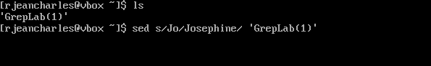
Command Breakdown
sed : Command name for stream Editor
s: command for substitution
/: delimiter that separates the substitution
Jo: the pattern that needs to be replace
Josephine: the pattern that should replace the substitution
/ : Final delimiter
‘GrepLab(1)’ : Finally target the file in question.

Before applying the command

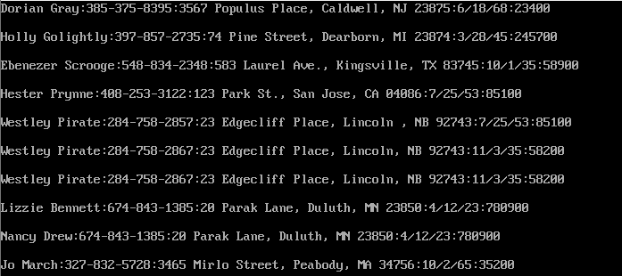

After applying the command
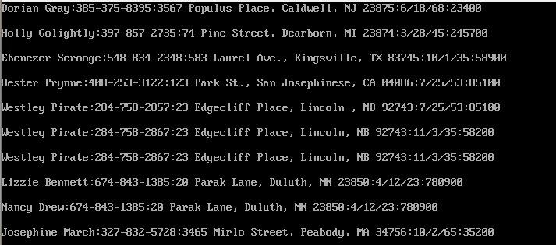

Keep original file
Create a new file to save the modification
sed s /Jo/Josephine/ ‘GrepLab(1)’ >> NewGrepLab

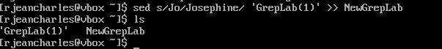
Command Breakdown
sed : Command name for stream Editor
s: command for substitution
/: delimiter that separates the substitution
Jo: the pattern that needs to be replace
Josephine: the pattern that should replace the substitution
/ : Final delimiter
‘GrepLab(1)’ : Target the original fille
>> operator to redirect the output to new file.
NewGrepLab : Create the new file

Verify the last 5 lines on the files using cat command

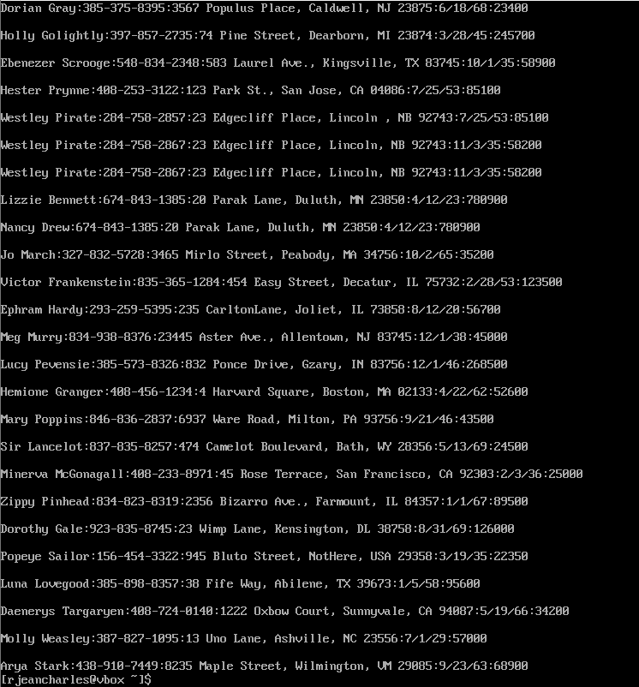

- Delete the last 5 lines.
Using sed command to delete the last 5 lines
sed -e :a -e ‘$d;N2,5ba’ -e ‘P;D’ ‘GrepLab’

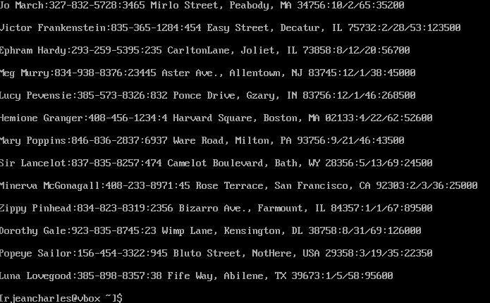

Break down the command
-e : Allows to read different operations into a single script or line
:a : create a label to be able to jump back to a loop
$d : verify if it’s the last line and delete.
N : append to the next line
1,5ba : Indicate that 5 lines should be delete while initiate the buffer
P: Print the oldest line in the buffer
D : Delete the first part of the buffer and continue as a loop
‘GrepLab(1)’ : Target the document being modified

- Print lines 3-15.
Print 3-15 lines using sed command
The command is sed -n '3,15p' ‘GrepLab(1)’
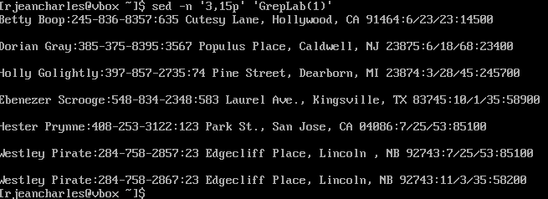

sed : Command name for stream Editor
-n : indicate to print only target what is mentioned
‘3,15p’ : the lines that should be print
p : print command
‘GrepLab(1)’ : Target the file that are used to read from.

Verify all the person living in california using cat command



- Delete lines for people who live in California

Used sed command to delete all files for people living in California
Sed -i ‘/CA/ ’ d‘ GrepLab(1)’

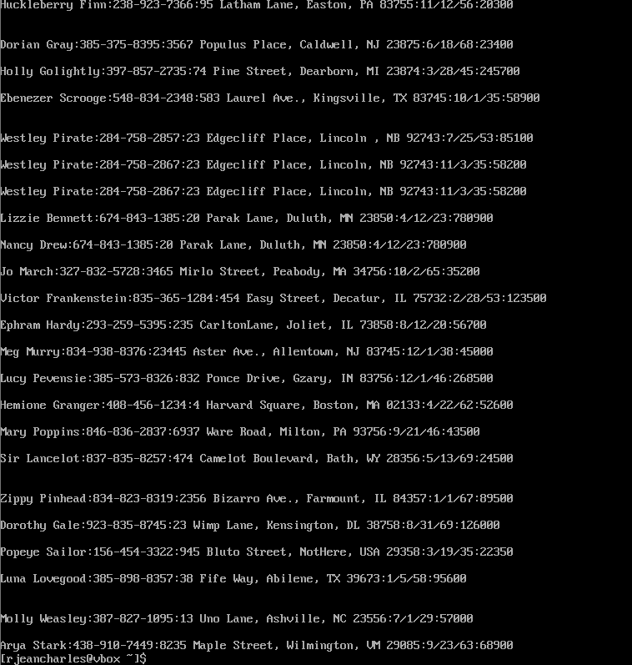

Break down command
sed : Command for stream editor
-i : modify file permanently
‘/CA/ ’ :look specifically for line with CA
d: delete all lines with the pattern
‘GrepLab(1)’ : Target file that is modified

- Print all lines where the birthdays are in the first week of the month.
Be careful of the dates for birthdays, the format is MM/DD/YY

Used sed command to print all lines where the birthdays are in the first week of the month.
Be careful of the dates for birthdays, the format is MM/DD/YY
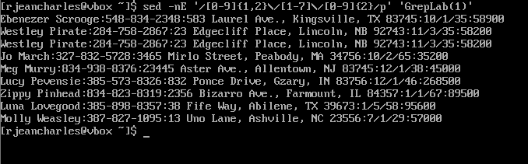
Breakdown of the Command:
-nE: indicated that only the specific pattern mentioned should be considered
/[0-1][0-9]\/0[1-7]\/[0-9]\{4}/: regular expression to find the date
[0-1][0-9] : Look for months and set up format 01-12
\/ : Escape first forward slash separator
0[1-7]: Set up day format 01-07 for first week
\/ : Escape second forward slash separator
[0-9]\{4\}:Correspond to 4 digit for year format
p: print the line that corresponds to the pattern

- Append three asterisks (*) to the end of lines starting with Sir
Used sed command to append three asterisks (*) to the end of lines starting with Sir
sed -i '/^Sir/s/$/***/' "GrepLab(1)"
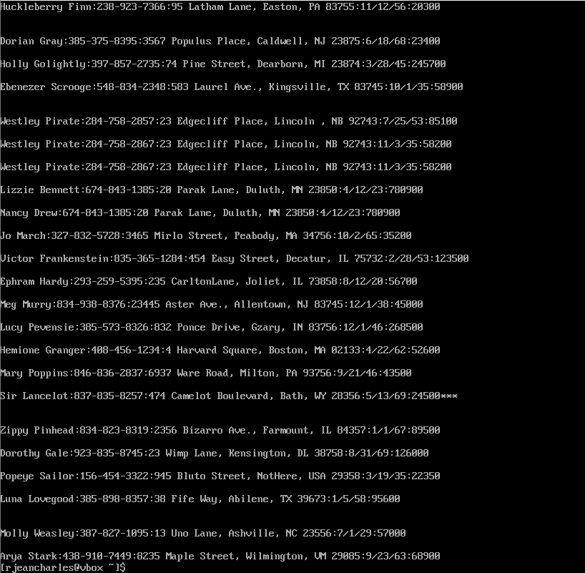

Breadown command
sed : command for Steam editor
-i : Modify permanently into file
/^Sir/ : indicate a specific expression
s: substitute command
$ : end of the line
*** : Text to enter
GrepLab : The file that being modified

- Replace the line containing ”Westley Pirate” with the phrase ”As you
wish.” Make sure you replace the whole line not just the name

Used sed command to replace the line containing ”Westley Pirate” with the phrase ”As you
wish.” Make sure you replace the whole line not just the name
sed ‘/Westley Pirate/c\As you wish. ‘GrepLab(1)’
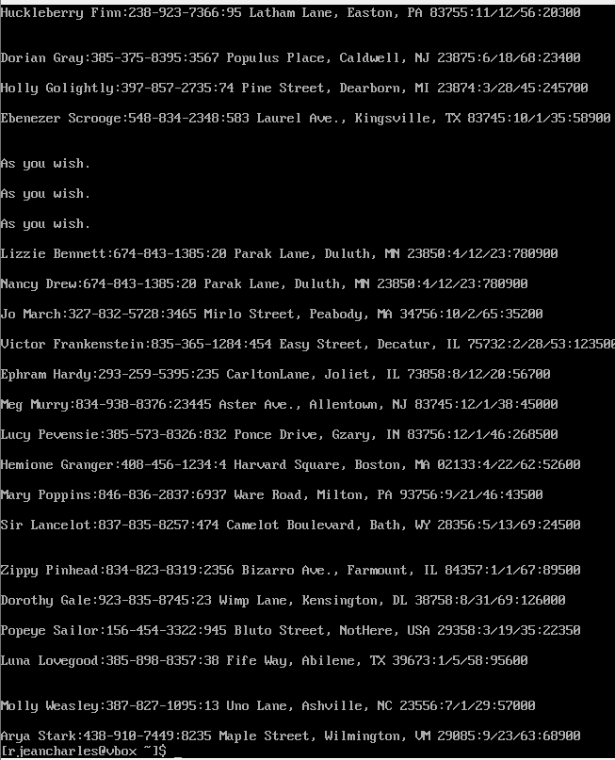

BreakDown the command
sed : Command for stream editor
‘/Westley Pirate/’ :the expression searched
c\ : The change command replaces the entire line that matches the expression that we are looking for with new text
As you wish : The new text to replace with
GrepLab(1): Target the file in question

- Change Minerva McGonagall’s birthday to 10/04/1935. Assume you
don’t know Minerva’s original birthday. Use a regular expression to
search for it.
Use sed command to Change Minerva McGonagall’s birthday to 10/04/1935. Assume you
don’t know Minerva’s original birthday.
Use a regular expression to search for it.
sed -i ‘ /Minerva McGonagall/s#[0-9][0-9]*/ [0-9][0-9]*/ [0-9][0-9]# 10/04/1935#’ NewGrepLab

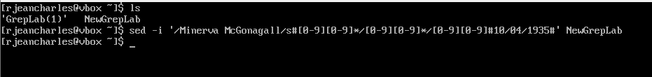
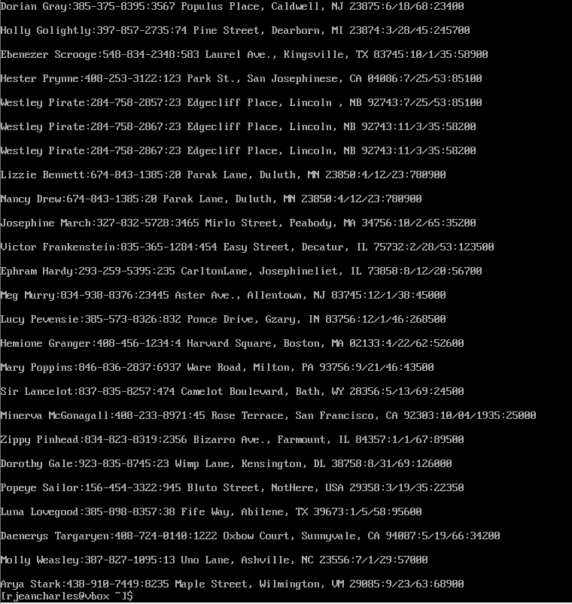

Breakdown command
sed -i : modified the file working on.
/Minerva McGonagall/ : the specific line where the substitution should be made
s : substitution command
#: delimiter, it is used instead of / because it’s part of the date format.
[0-9][0-9]*/ [0-9][0-9]*/ [0-9][0-9]:looking for the old date format
10/04/1935 : Add the new date format on the lines
NewGrepLab : Target the file reading from.

9. Delete all blank lines.
Use sed command to delete all blank lines
sed /^$/d NewGrepLab
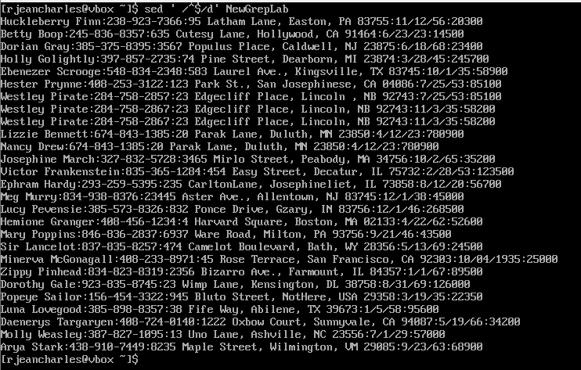

Breakdown command
sed : command for stream editor
/^$/ : empty line which is the specific expression to modify or erase
d : delete
NewGrepLab : Target the file reading from.
- Write a sed script that will (actual sed script, NOT just the commands
on the command line)
(a) Insert above the first line the title - Great Literary Characters -.
(b) Print the contents of the file, but instead of the phone number
starting with an area code, have it start with a 1+, then include
the area code and number. For example, (603)123-1234 would
turn into 1+(603)123-1234
(c) Append at the end of the file ”Happily Ever after. The End”

Use nano command to create script
Type the script

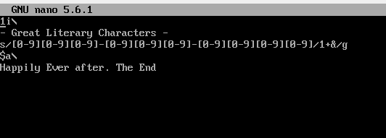
Break Down Script
1i : refer to line 1 and insert text in it
- Great Literary Characters - : Literal text to add as title
s/ : command for substitution start
[0-9][0-9][0-9]-[0-9][0-9][0-9]-[0-9][0-9][0-9][0-9] : Phone number format as pattern
/1+&/: New string to replace the old string
1+ : Should be add in front of the phone number
& : Refer to the entire string format in this case the phone number.
g: make sure to update all phone numbers even if there a multiple for one individual
$ : Target last line of file
a\: append command that indicates the following text is in the next line.

Verify Script with Sed command
sed -E -f script.sed ‘GrepLab(1)’

Break Down command for script verification
sed : command use for stream editor
-E: allow using multiple symbols without repeating backslashes.
-f: The commands to be executed are located in file
script.sed: name of file containing the script command
‘GrepLab(1)’ : The file where the input text to process is being located

The Scirpt file open with the modification required
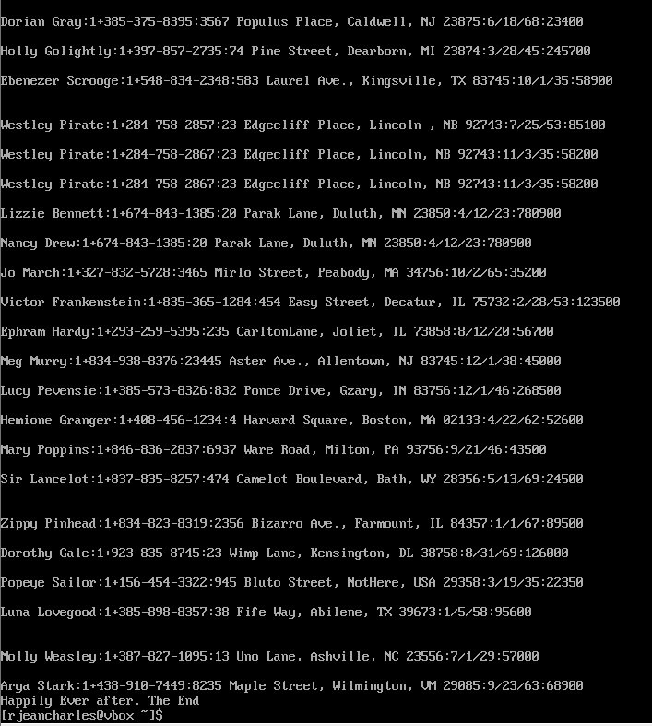

References

https://www.gnu.org/software/sed/manual/sed.html#sed-script-overview
https://www.geeksforgeeks.org/linux-unix/sed-command-in-linux-unix-with-examples/

